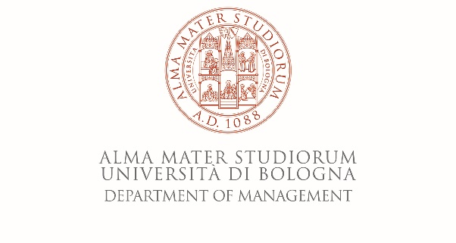

The Department of Management (DISA) of the University of Bologna launches the call to apply for 6 study awards to students enrolled in the following study programs:
- Students enrolled in 2021-22 on their second year of Resource Economics and Sustainable Development (RESD, Campus of Rimini), Tourism Economics and Management (TEAM, Campus of Rimini), Service Management (SEM, Campus of Rimini), and Economia e Commercio (CLAMEC, Campus of Forlì);
- Students enrolled in 2021-22 on their third year of Corso di Laurea Triennale in Economia e Commercio – curriculum in Management (CLEC-M, Campus of Forlì).
The awards consist in participating to an Intensive Study Program (Winter School) for university students regarding the topic of Integrated Reporting, a new reporting approach that helps firms to better disclose sustainability information and the creation of value. The Intensive Study Program provides students with lectures, seminars, and teamwork activities focused on specific case studies, all related to the main topic of Integrated Reporting. Students selected from five different European universities will have the opportunity to participate to the Intensive Study Program and enjoy an international atmosphere, while increasing their knowledge on sustainability and corporate reporting. The activities of the Study Program are offered by the INTEGRES (Integrated Reporting and Education for Sustainability) project which is financed by the Erasmus Plus European Program. Professors belonging to the INTEGRES Team will give lectures and present case studies. The official language is English.
The project will take place at Avans Hogeschool (Breda, Netherlands- www.avans.nl) from the 15th of November 2021 to the 19th of November 2021.
Each winner will be reimbursed for travelling and staying costs for a total of up to 750€ to participate at the Intensive Study Program. To take part, participants must send an email from their institutional email at michela.bega2@unibo.it with the object “Partecipazione_progetto INTEGRES”.
The message must contain the following attachments in a single PDF file:
1) Application form (Allegato 1) filled in and signed;
2) Self-certification of passed exams during Bachelor and Master programmes with relative grades;
3) Motivational letter to take part at the project;
4) Copy of ID document;
5) Certification of English proficiency (if obtained).

Deadline for sending the application: 20th of July 2021.
The ranking list of winners will be published by the 3rd of September 2021 at https://bandi.unibo.it

For administrative information, write an e-mail to michela.bega2@unibo.it.
For more information on the winter school, the contact person for the University of Bologna is Professor Selena Aureli. For details regarding the INTEGRES programme students can check at the following link: “INTEGRES -Integrated Reporting and Education for Sustainability Project”

